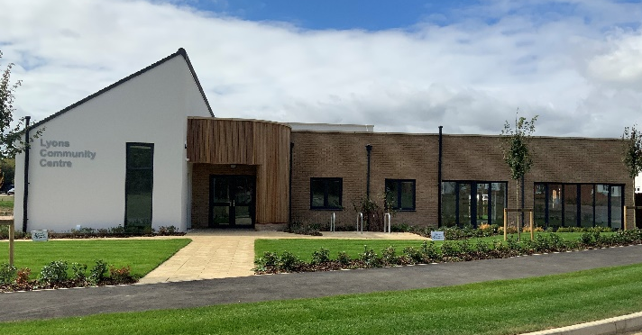
Lyons Community Centre
33A Mallard Crescent
Caddington
Luton
Bedfordshire
LU1 4FG

Block Booking Hire Form

TO BE COMPLETED BY THE HIRER (PLEASE COMPLETE ALL FIELDS)
Name of group/ organisation
Name of hirer

Address for invoice inc postcode

Daytime Tel No. |  | Evening Tel No.
Do any members of your group have a disability?

DETAILS OF BLOCK BOOKING (PLEASE COMPLETE ALL FIELDS)
Activity

Room required

Approx number of attendees
Day of hire

Times of hire

First date required

Number of weeks required
List of dates not required and reason (ie: term time etc.)

Does your group have the below information | Yes/No | Please provide copies to confirm your booking and enter details below
Public Liability Insurance

Disclosure and Barring Service (DBS)

Risk Assessments

Child Protection Policies

Methods of Payment:

As per instructions on your invoices. Please read these carefully.
Please return all forms and copies of relevant documentation and retain the conditions of hire for your information.

I have received and read all the conditions of hire and abide by them. I have retained a copy for my information.

Name: .........................................................................................................

Signature: ....................................................................................................

Date: ............................................................................................................

